

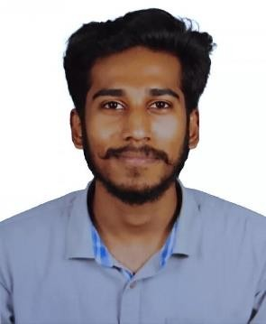

**Curriculum Vitae**

**Hareesh Yagnamurthy**

Personal Details.

|  |  |
| --- | --- |
| Name Employee ID | Hareesh Yagnamurthy  46180162 |
| Designation | Analyst / Software Engineer – A4 |
| Birth Date | 16-11-2000 |
| Residence | Nellore, Andhra Pradesh |
| Nationality | Indian |
| Marital Status | Single |
| Gender | Male |

Profile

Designation Analyst

BU LP AS US

DOJ 06th January 2022

Technical Skills

|  |  |
| --- | --- |
| Web Tools | HTML, CSS |
| Languages | C# (Intermediate), .NET(framework) |
| Database  Third Party Tools ASP.NET Technologies | SQL  Visual Studio, SQL Express MVC (Intermediate Level)  Entity Framework (Intermediate) Web API (Intermediate Level) Webforms (Beginner Level) |
| Operating Systems Version Control | Windows, Linux, Android GIT |

Languages

|  |  |  |  |
| --- | --- | --- | --- |
| Languages | Speak | Read | Write |
| English | Proficient | Proficient | Proficient |
| Telugu | Proficient | Proficient | Proficient |
| Hindi | Moderate | Moderate | Moderate |

.

Experience

**From To**

|  |  |
| --- | --- |
| Project Name | Faculty Information system |
| Client | Part of Training 1 |

|  |  |  |
| --- | --- | --- |
| Role | .Net Core Developer | |
| Roles performed | Development and Design of Web Application | |
|  | C #.Net | Visual Studio |
| Database | SQL Server |
| MVC Core | Visual Studio  Google(localhost) |
| Web API | Postman, Swagger |
| Description | The proposed Faculty information System (FIS) is a web based application which enables Administration  ,Student and faculty are logged into the application and view the faculty information and manage data.  The System first develops the Console Code using  3-tier Architecture Technology in .Net Core. Then the UI and Webpage is completely done by using ASP.NET MVC, Web API.  In UI, the user can login and register according to their requirement and access the service. | |

|  |  |
| --- | --- |
| Training attended | :- Done Internal Training in .Net Core . |

|  |  |  |  |
| --- | --- | --- | --- |
| Education . |  | | |
| **1. B Tech (Mechanical Engineering)** | | |  |
| Name of the Institution | | Sree Venkateswara College of Engineering, Nellore |
| Years of study | | 2017 - 2021 |
| Aggregate | | 6.7CGPA |
| 2. **Intermediate** | | |
| Name of the Institution | | Narayana Junior College, Nellore |
| Years of study | | 2015 - 17 |
| Aggregate | | 95% |
| **3. SSC** | | |
| Name of the Institution | | Ratnam High school, Nellore |
| Years of study | | 2014-15 |
| Aggregate | | 92% |

Contact Details .

Permanent Address Venkatareddy Nagar, Vedayapalem, Nellore,

Andhrapradesh, 524004

Mobile +91 8074493265

Corporate Email [hareesh.yagnamurthy@capgemini.com](mailto:hareesh.yagnamurthy@capgemini.com)